Total Score
_______ / 50 points
A  [Track 09] Listen to the conversation between Lucy and Nick. Check () the four facts that are true about Nick.
Nick . . .
a.  is in Lucy’s history class. | e.  studies environmental science in college.
b.  is going to graduate next year. | f.  had an interview at a wind farm yesterday.
c.  started to look for jobs last week. | g.  drove for two hours yesterday.
d.  thinks nuclear energy is dangerous. | h.  liked the people he met yesterday.
A _______ / 8 points (2 points each)
B Complete the sentences with the correct words from the box.
bills | energy | faucet | pollution | transportation | warming
1. I pay all my _____ bills _______________ online, so I don’t have to waste gas driving
to the post office.
2. If you have a leaky ____faucet_____, I know someone who can fix it.
3. I use public ___ transportation __, so I don’t get stressed in traffic every day.
4. Bikes are good for the environment because they don’t cause _pollution.
5. Summers are much hotter here now. Some people say it’s because ofglobal __warming.
6. A lot of people in my country use solar __energy to heat the water in their homes.
B _______ / 6 points (1 point each)
C Circle the correct quantifiers to complete the paragraph.
Today I read a newspaper article about environmental problems. The first problem
is that there are fewer / too many regular cars on the road and not enough / less
¹
²
hybrids. The second problem is that our towns and cities need to give us
more / too many recycling bins so that too many / more people will recycle glass,
³
⁴
metal, and paper. The writer also believes that there is not enough / too much
⁵
e-waste in our landfills.
But the news isn’t all bad. One good thing is that our shopping habits are
improving. People are starting to buy less / fewer plastic bottles, and we are also
⁶
using more / less cloth shopping bags. Another good thing is that people are
⁷
beginning to understand that CFLs are good for the environment because they
use less / not enough energy than regular lightbulbs.
⁸
C _______ / 8 points (1 point each)

D Complete the first conditional sentences with the words in parentheses and the correct form of the verbs. Use contractions where possible.
1. If _______________________________ (we / take) the subway,
_______________________________ (we / not / sit) in traffic.
¹
2. _______________________________ (they / save) money on gas
²
if _______________________________ (they / buy) a hybrid car.
³
3. If _______________________________ (she / buy) local food,
⁴
_______________________________ (she / help) the environment.
⁵
4. _______________________________ (you / not / waste) energy
⁶
if _______________________________ (you / use) CFLs.
⁷
5. If _______________________________ (it / rain) tomorrow,
⁸
_______________________________ (I / not / use) the clothesline
⁹
to dry my clothes.
¹⁰
D _______ / 10 points (1 point each)
E Number the lines of the conversation in the correct order.
____ A: Hi, Fred. Did you hear the news? I sold my car and bought a bicycle.
1
____ A: I’d say about 20 minutes. My office is only five kilometers from my
house. On the weekends, we use my wife’s hybrid. We bought it
last year, and she loves it!
____ A: Actually, I’d rather not say. But we’re really happy we bought it.
____ B: Good for you! How long does it take to get there?
____ B: You’re kidding! Why did you do that?
____ B: I didn’t know you bought a hybrid. Can I ask you how much it cost?
____ A: Well, I wanted to do my part for the environment. I ride the bike to
work now.
E _______ / 6 points (1 point each)
F Read the webpage. Complete the text with the letters of the correct sentences from the box.
A I ride my bike to class every day
B I stopped using regular lightbulbs a few years ago
C I buy only organic food
D I use it as often as I can
E I like my hybrid, but I don’t use it every day
F I take my own cloth bags

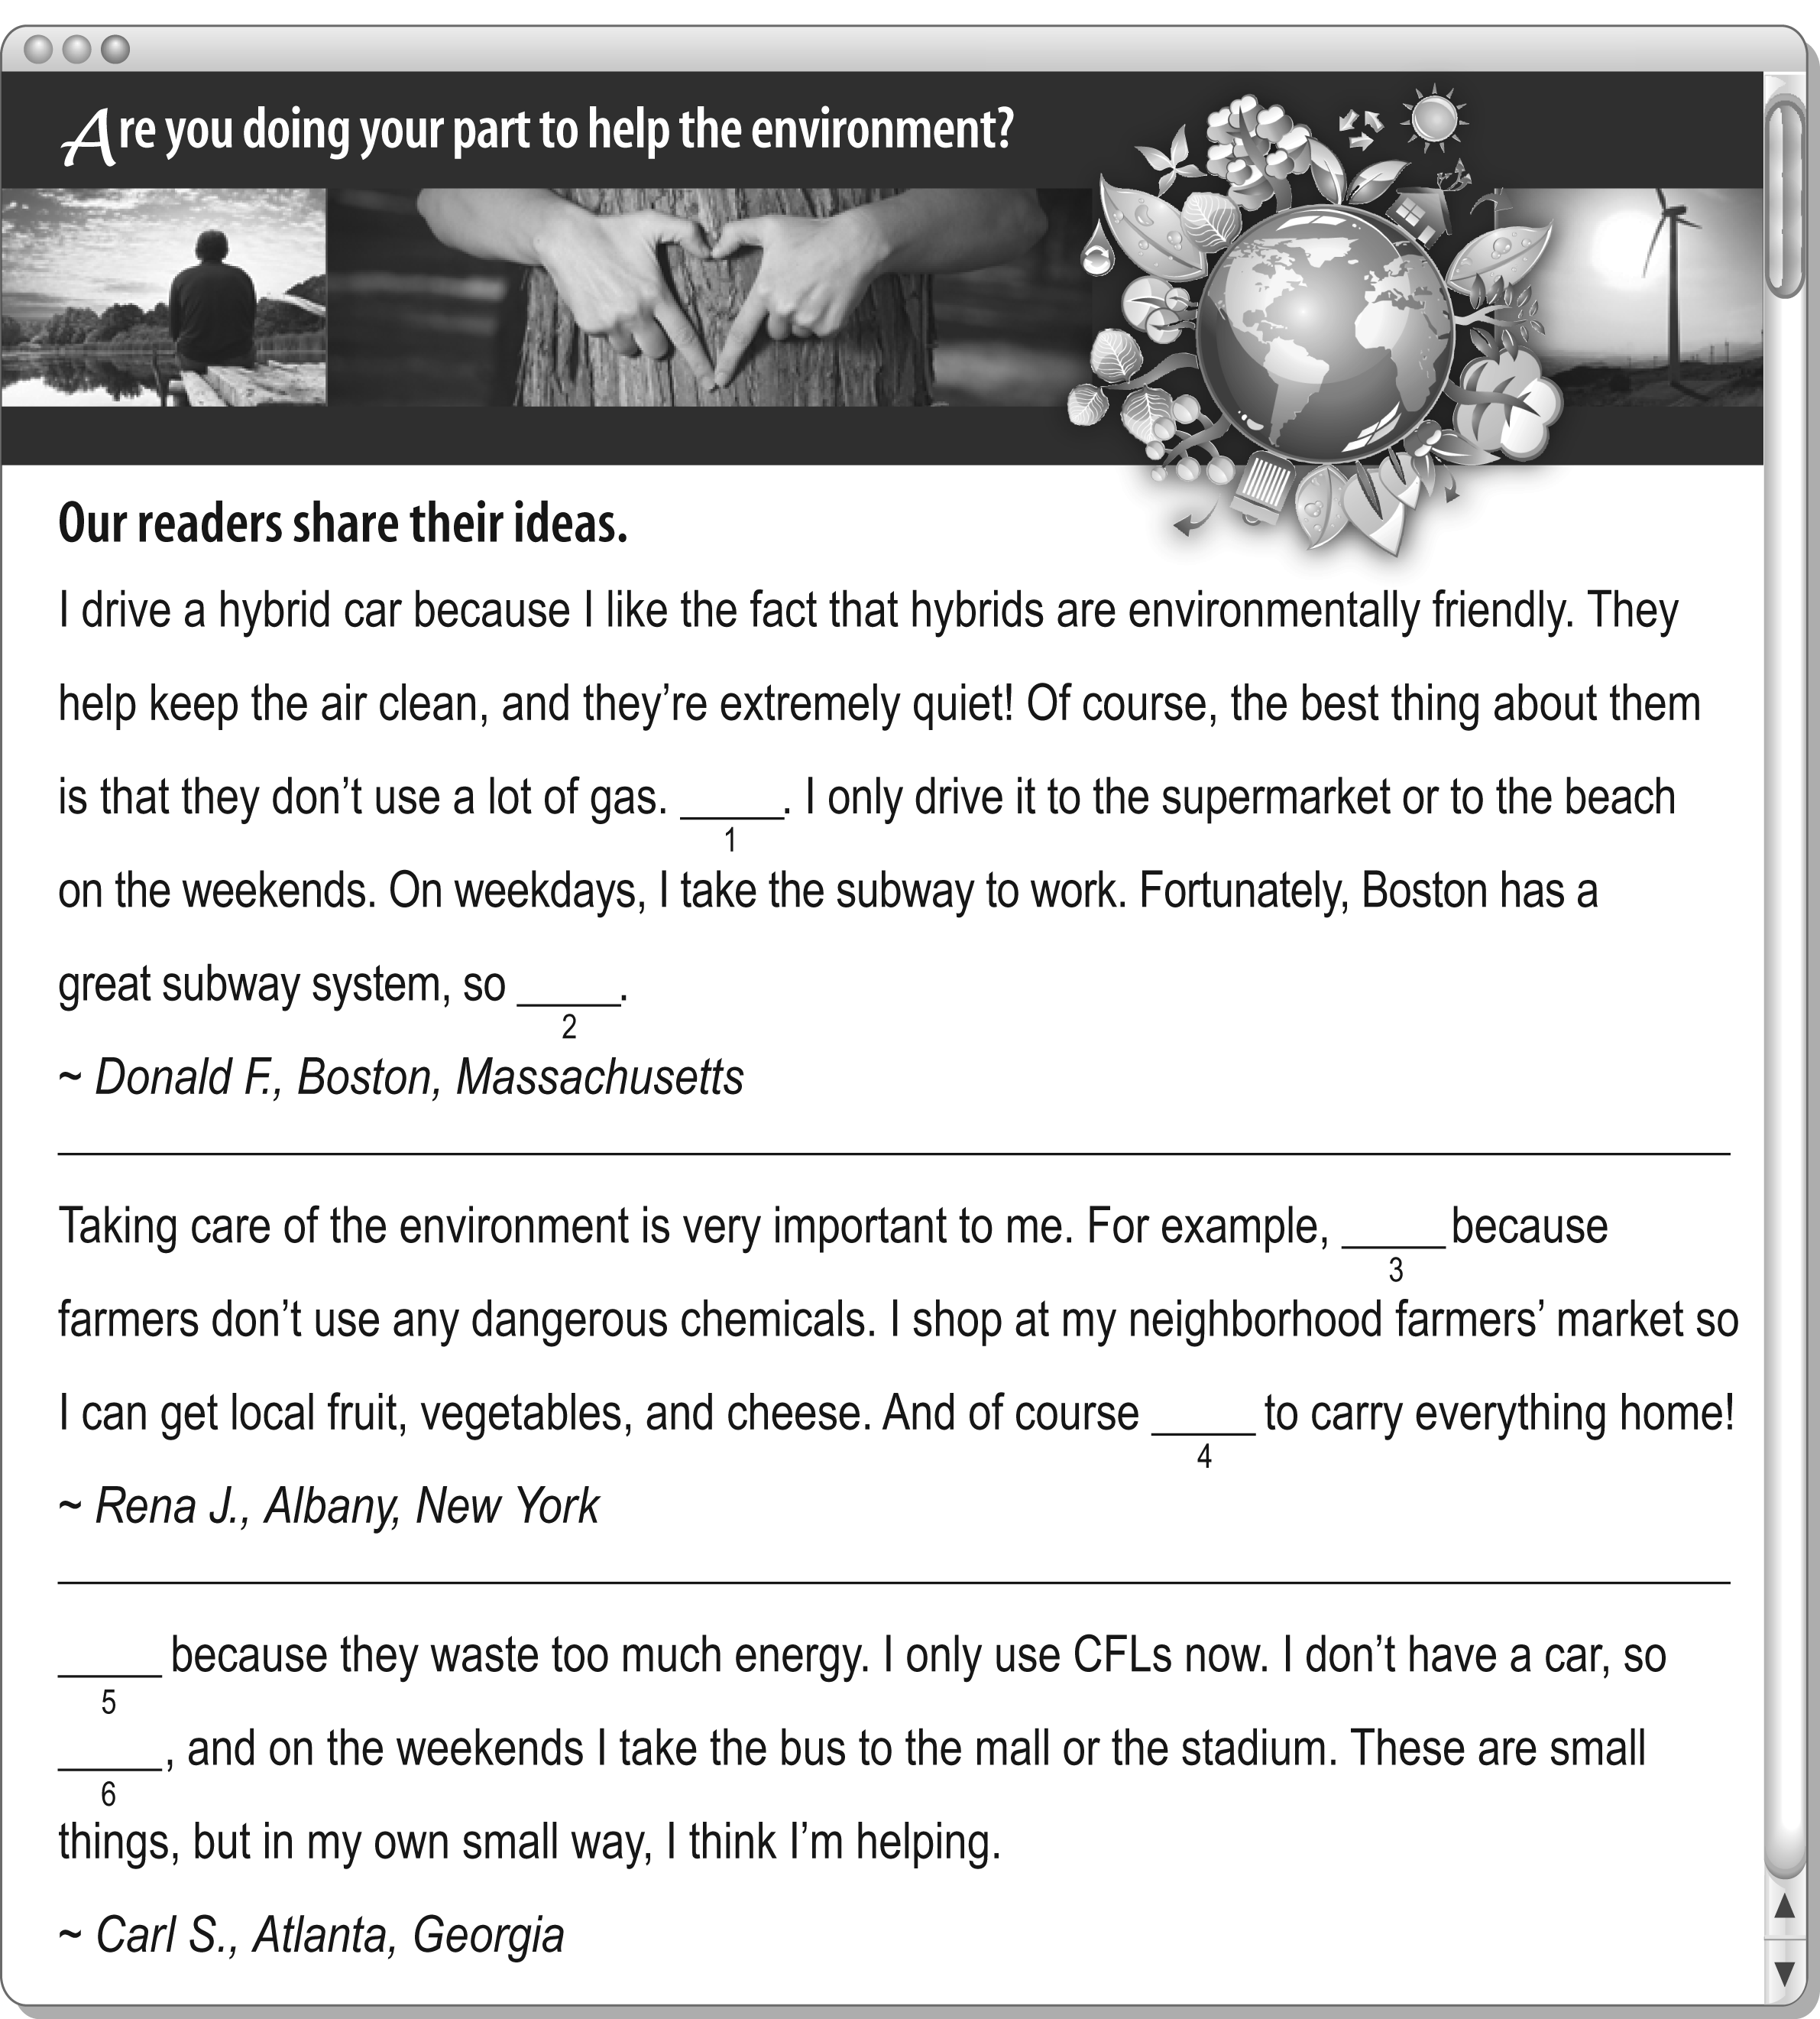
F _______ / 12 points (2 points each)

